Adding Indices as Bands to GEE

The idea is to add five vegetation indices: NDVI, EVI, MSAVI, NDMI, NBR and one urban index: NDBI to the band collection extracted from GEE, and potentially a water related index as well (NDWI).

As a reminder: the Sentinel Band Information (https://blogs.fu-berlin.de/reseda/sentinel-2/)

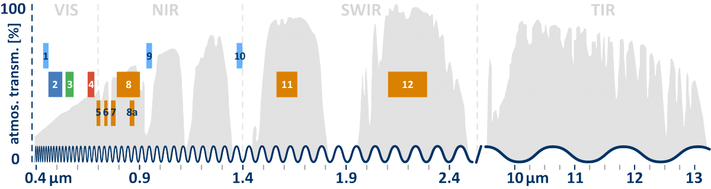

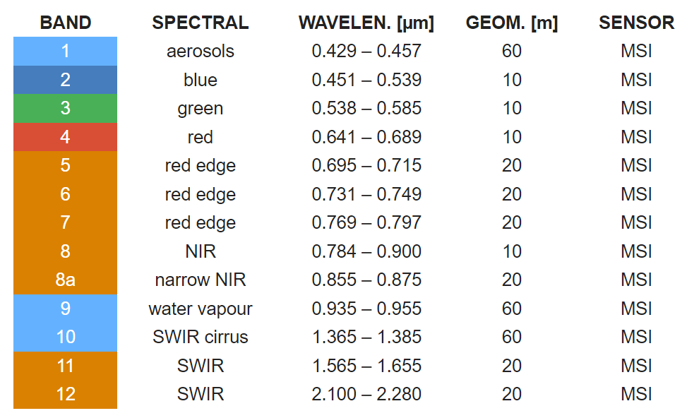

Reflectance derived Indices

There are many indices, but these six indices are the most commonly used and have a good signal strength to be used as features in a Machine Learning exercise to extract insight from a satellite image

Normalised difference vegetation index (NDVI): NDVI is used to quantify vegetation greenness and is useful in understanding vegetation density and assessing changes in plant health. NDVI is calculated as a ratio between the red (R) and near infrared (NIR) values in traditional fashion: (NIR - R) / (NIR + R)

Sentinel 2: (B8 - B4) / (B8 + B4)

Enhanced Vegetation Index (EVI): EVI is an 'optimised' vegetation index designed to enhance the vegetation signal with improved sensitivity in high biomass regions and improved vegetation monitoring through a decoupling of the canopy background signal and a reduction in atmosphere influences.
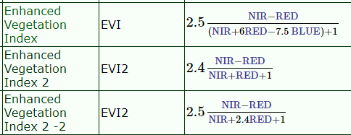
EVI2 is developed for product comparison, and is based on two bands only, the recommendation is to use EVI when in a single product configuration.

Sentinel 2: 2.5 * (B08 - B04) / ((B08 + 6.0 * B04 - 7.5 * B02) + 1.0)

Modified Soil Adjusted Vegetation Index (MSAVI): MSAVI is an index designed to substitute NDVI and NDRE where they fail to provide accurate data due to low vegetation or a lack of chlorophyll in the plants. During the stages of germination and leaf development, there is a lot of bare soil between the seedlings.
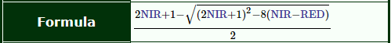
MSAVI2 = (1/2)*(2(NIR+1)-sqrt((2*NIR+1)^2-8(NIR-Red)))

Sentinel 2: (1/2) * ( 2*(B8+1) - sqrt( (2*B8 +1)^2 - 8*(B8-B4) ) )

Normalised Difference Moisture Index (NDMI): NDMI is used to monitor changes in water content of leaves and is an indication for droughts and can be used to detect irrigation.
NDMI is computed using the near infrared (NIR) and the short wave infrared (SWIR) reflectances, there is some confusion in the literature, and sometimes this ratio is referred to as Normalised Difference Water Index (NDWI), but the correct use of this index is combining GREEN-NIR, instead of the SWIR1.


Sentinel 2: (B08 - B11) / (B08 + B11)

Normalised Burn Ratio (NBR): NBR is used to identify burned areas and provide a measure of burn severity. It is calculated as a ratio between the NIR and SWIR2 values in traditional fashion. The NBR is very similar to the NDMI but the wavelength is significantly different (Wavelengths: 1400-3000), and while the SWIR1 is used for agriculture; finding water stress in plants, SWIR2 is useful for measuring the moisture content of soil and natural vegetation, and it provides good contrast between different types of vegetation. The two indices compliment each other when trying to detect a change in vegetation over time.

Sentinel 2: (B08 - B12) / (B08 + B12)

Normalised Difference Built-Up Index (NDBI): The NDBI is a remote sensing index used to assess and analyse urban development and the extent of built-up areas within a region. The NDBI uses the NIR and SWIR bands to emphasise manufactured built-up areas, and it highlights urban areas with higher reflectance in the shortwave-infrared spectral range (SWIR).It is ratio based to mitigate the effects of terrain illumination differences as well as atmospheric effects: (SWIR - NIR) / (SWIR + NIR)

Sentinel 2: (B11 - B08) / (B11 + B08)

Normalised Difference Water Index (NDWI): For completeness, the NDWI is used to monitor changes related to water content in water bodies. As water bodies strongly absorb light in the visible to infrared electromagnetic spectrum, NDWI uses green and near infrared bands to highlight water bodies. Including this index in the model will give a good contrast to where either roads or vegetation plots are, but it can result in over-estimation of water bodies.

Sentinel 2: (B03 - B08) / (B03 + B08)

Testing the Indices in QGIS
Seeing the different indices is useful to get an idea of what they could mean for the model. The two images below are from the same location, as extracted in the previous iteration and will be used throughout this section.

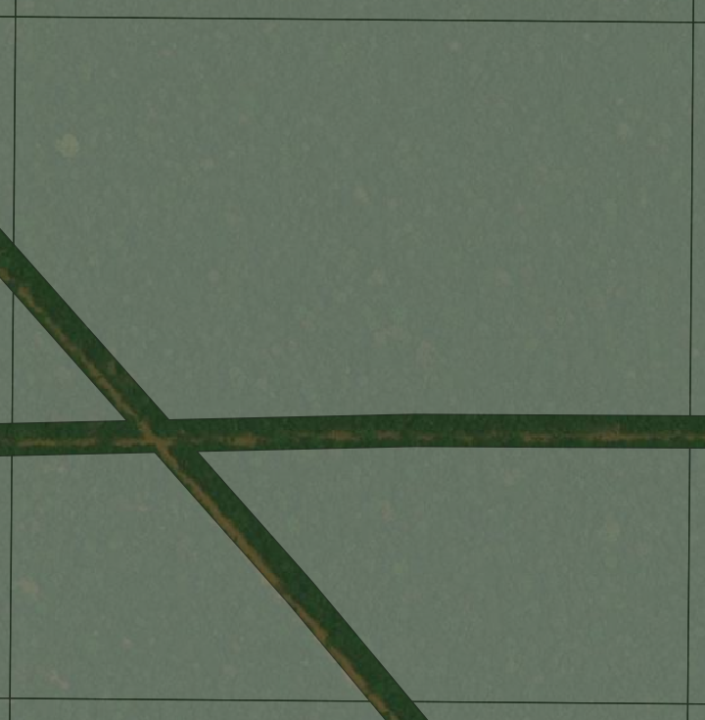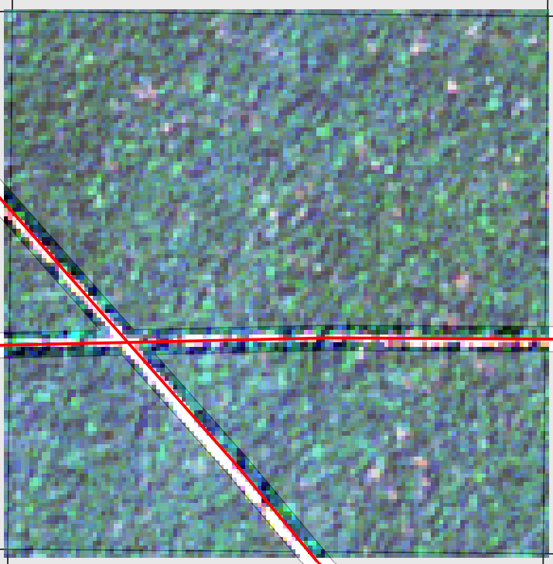
Left: To illustrate that higher resolution is not always the better option: ESRI high resolution satellite basemap overlaid with the ISL mask for image patch GID_ISL_057_10_5 (transparent grey).
Right: Image patch GID_ISL_057_10_5 overlaid with the label for this area (red line), and the same mask.

In the rest of the section the Sentinel 2 image will be at the left, and the index at the right without the mask applied to see the whole patch in the correct colours.

NDVI
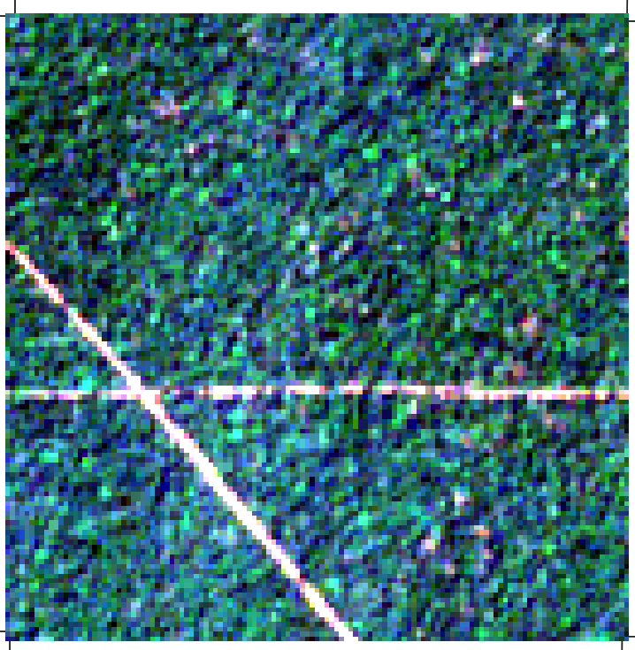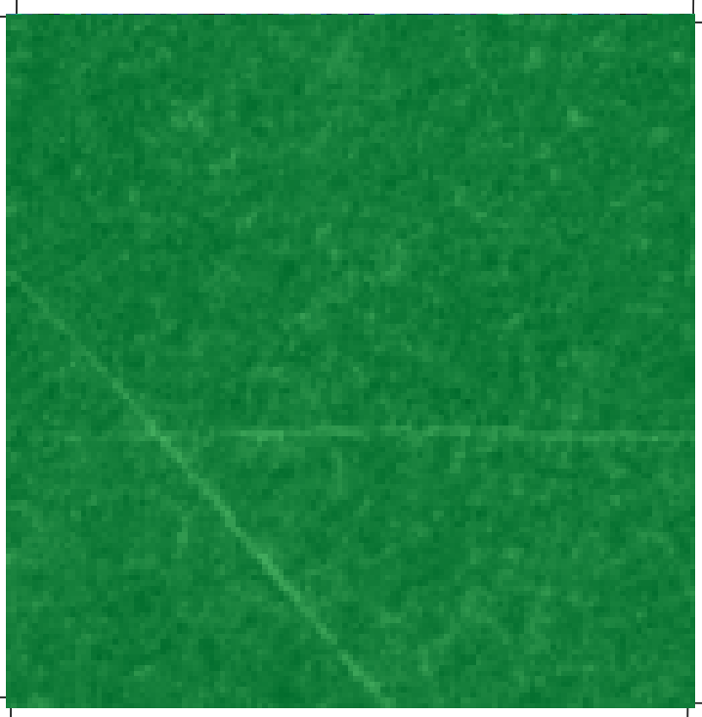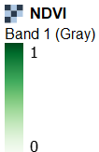
There is a slight draw-back with this index, the range is from -1 to 1, and the minimum value in this image is 0.6, indicating deep vegetation, but the roads are clearly visible.

Sentinel 2: (B8 - B4) / (B8 + B4)

EVI
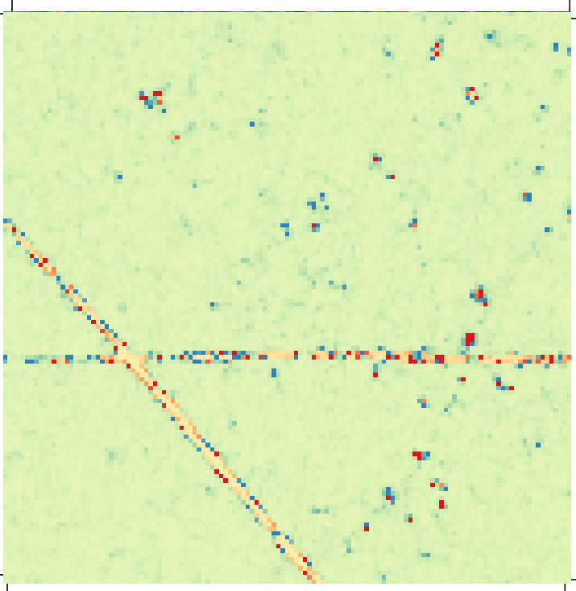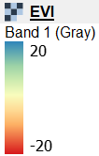
Show in the image is a subset [-20:20] of the full data range:
- STATISTICS_MAXIMUM=1553.75
- STATISTICS_MEAN=4.1476202006275
- STATISTICS_MINIMUM=-774.0625
- STATISTICS_STDDEV=17.245924673885
Most of the data points are around the mean and within the first standard deviation. Also in this image the road is clearly visible.

Sentinel 2: 2.5 * (B08 - B04) / ((B08 + 6.0 * B04 - 7.5 * B02) + 1.0)

MSAVI
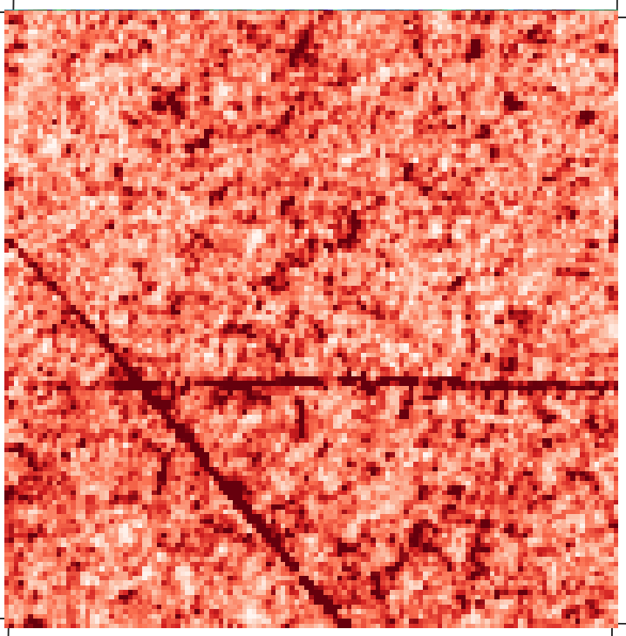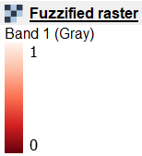

Note: the MSAVI is not a normalised index, and the ranges can vary from image patch to image patch but normalisation shows the low values in deep red (linear fuzzy membership 1.32 - 1.44 to [0:1]).

Sentinel 2: (1/2) * ( 2*(B8+1) - sqrt( (2*B8 +1)^2 - 8*(B8-B4) ) )

The three next images are using the SWIR (Bands 11 and 12) and the direct result of using these bands is that the resolution is changing from 10m to 20m, not in the raster metadata but in the values. When extracting the data from Sentinel Hub the original data is at 20m but when combining them the highest resolution is used, and the 20m grids are divided (without interpolation) into 4 new squares, when doing the same operation in GEE the nearest neighbour is selected, effectively bring the original values over to the new grid. This is what can be seen in the next images, the road is less detailed, because instead of having an unique value the same value is used 4 times calculations, and therefore the local differences are not as extreme as in the previous images.

NDMI
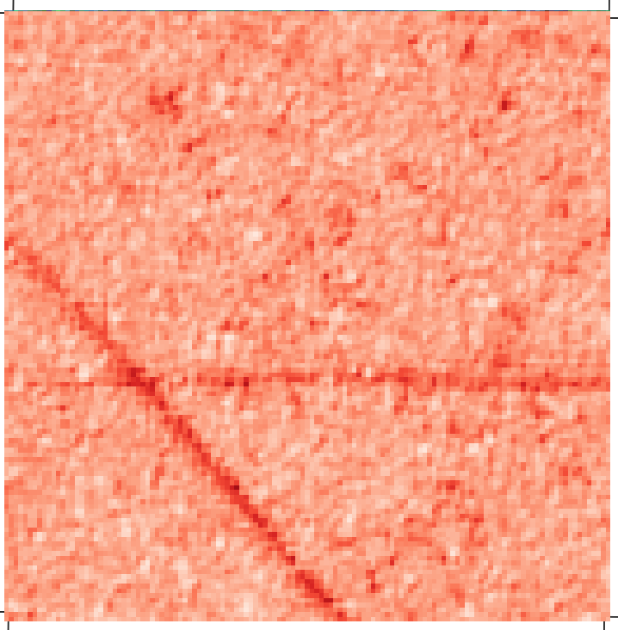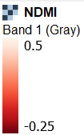
Sentinel 2: (B08 - B11) / (B08 + B11)

NBR
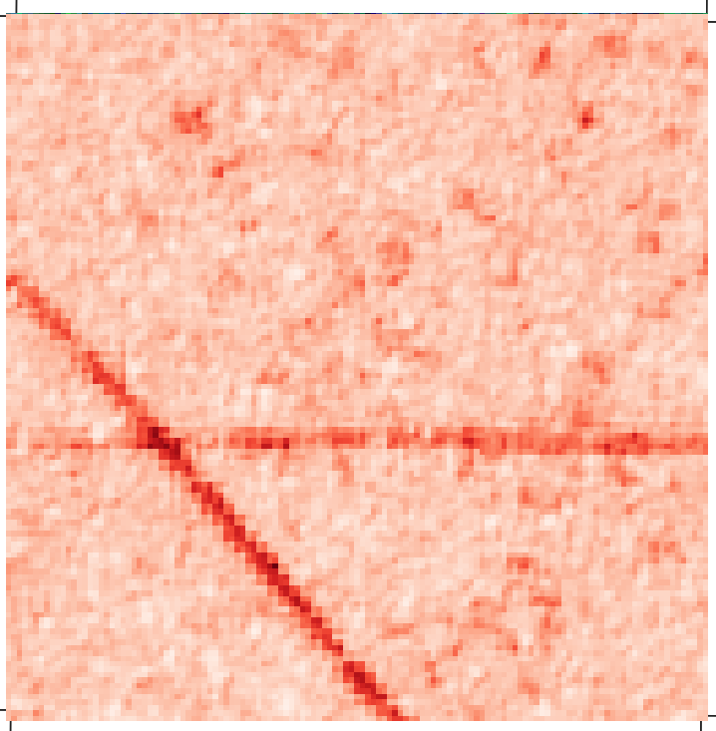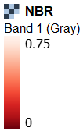
Sentinel 2: (B08 - B12) / (B08 + B12)

NDBI
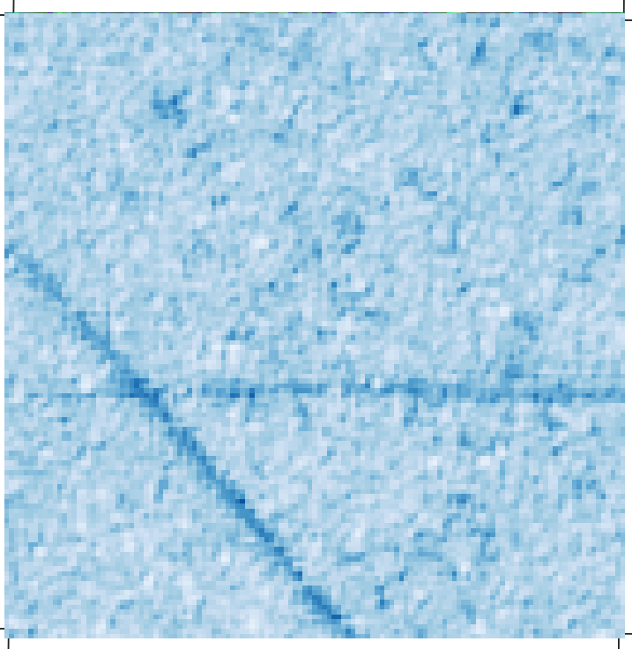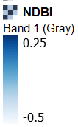
Sentinel 2: (B11 - B08) / (B11 + B08)

NDWI
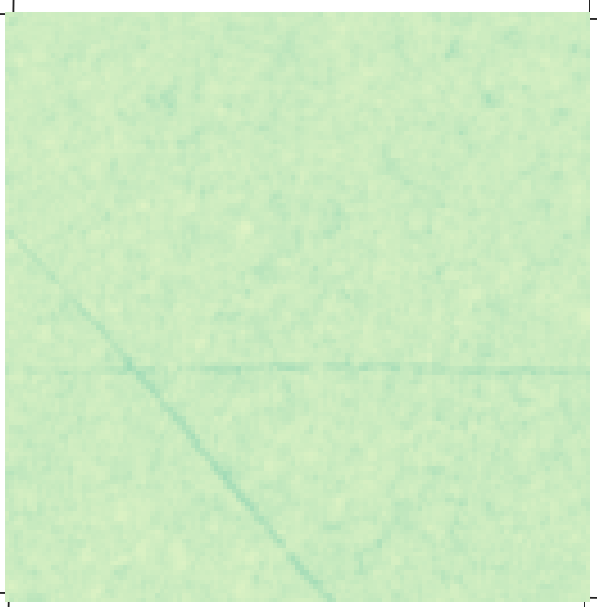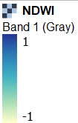
In this example the range is set to exactly match the data domain [-1 - 1], and the road is less visible than in the other examples, but this can be corrected to select the correct range for the effect or feature, in NDWI all values above 0.5 are permanent water bodies, and obviously there are not permanent water bodies. Natural vegetation has values between -1 and -0.75, and excluding the vegetation give the following image:
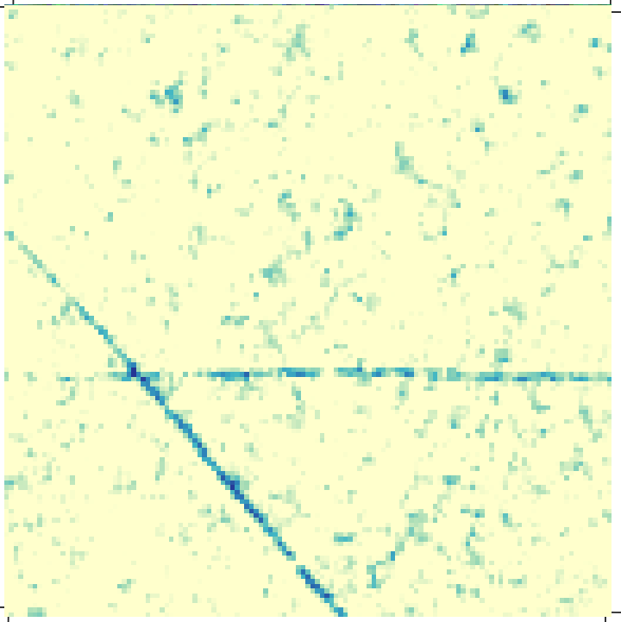

Sentinel 2: (B03 - B08) / (B03 + B08) with Data Range [-0.70:-0.50] for the second image

References:

https://www.indexdatabase.de/

https://blogs.fu-berlin.de/reseda/sentinel-2/

https://custom-scripts.sentinel-hub.com/custom-scripts/sentinel/sentinel-2/

https://gisgeography.com/sentinel-2-bands-combinations/

Interpretation of the modified soil-adjusted vegetation index isolines in red-NIR reflectance space DOI:10.1117/1.2709702

